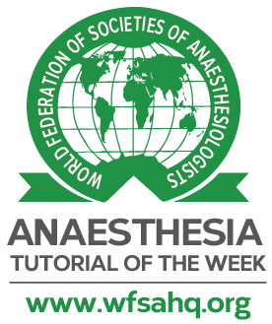
Final Submission Checklist

Anaesthesia Tutorial of the Week

This form should only be completed once the final draft of your tutorial has been finished and accepted by the editorial team. Please do not send this form to us before this time.

The completed form can be sent either to atotw@wfsahq.org or to your supervising primary editor on the ATOTW editorial board. Thank you again for all your hard work!

By returning this form, you confirm the following;
You have read and followed the Tutorial Writing Guidelines from our website. In particular:
Submit manuscript in Word Document
Submit tables, figures, images in separate Word document
There are 3 to 5 important points for the “Key points’
All formatting is correct, as described in the Tutorial Writing Guidelines
There are 20 true/false questions
Answers to the questions are correct and explanations are provided

The content of this tutorial is your original work, unless stated
Any work that is not original (e.g. figures / diagrams) has permission from the original source, and this is stated within the tutorial
This tutorial has not been submitted for publication elsewhere
You agree to the Creative Commons 4.0 copyright policy of ATOTW and the WFSA
You agree to being contacted in the future by the ATOTW in reference to this tutorial. Please inform us if the e-mail address you have provided is no longer valid.

Tutorial Title:

Subsection:

Date of final submission:

Finally, in no more than 40 words, could you please provide a brief description of what this tutorial cover. Please include a picture that you would like to appear alongside your tutorial when it gets published online – this can be a figure from your tutorial.

Picture:

Brief description of tutorial:

Please list up to 8 keywords associated with tutorial:

Your name:

Your contact e-mail address:
Co-author’s email:
Primary editor’s email:

