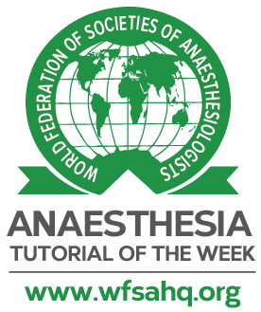
Tutorial Registration Form

Anaesthesia Tutorial of the Week

This form must be completed prior to starting work on a tutorial for Anaesthesia Tutorial of the Week. However, please only send the completed form once your tutorial has been agreed by the editorial team. If your tutorial has not yet been agreed, please contact us at atotw@wfsahq.org giving your name, contact details and a tutorial topic that you would like to cover.

Please either print and scan the completed form, or complete it electronically. All completed forms should be sent to atotw@wfsahq.org. We will contact you with confirmation of receipt of the form.

Tutorial Title:

Subsection (delete as applicable):
General / Intensive Care / Paediatrics / Obstetrics / Pain / Regional / Basic Science / Patient Safety

First author name:
First author hospital and country:
First author e-mail address:

Second author name (if applicable):
Second author hospital and country (if applicable):
Second author e-mail address (if applicable):

Supervisor’s name (if applicable):
Supervisor’s hospital and country (if applicable):
Supervisor’s e-mail address (if applicable):

ATOTW primary editor name:

Today’s date:

Proposed date for completion of first draft:

Please ensure that you read and follow the ‘Tutorial Writing Guidelines’ available on the Authors Page of our website:
http://www.wfsahq.org/atotw-authors-page

